‘EXCELLING IN RESEARCH, WE SERVE THE SOCIETY’

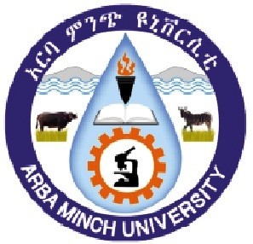
AMU PROFILE IN A NUTSHELL
Arba Minch University is located in Arba Minch town which is located 505 km South West from Addis Ababa, the capital of Ethiopia. It’s nestled at the foot of Gamo Mountain ranges facing huge Abaya and Chamo Lakes in idyllic surroundings forms the part of East African Rift Valley.
The university was established initially as Arba Minch Water Technology Institute (AWTI) in 1986 to address water-related issues. Then, AWTI used to offer short & long-term trainings, conducting research and rendering consultancy services in water sector.
AWTI got functional in September 1986 by enrolling 181 students in two first degree, two advanced diploma and two diploma programs with a purpose to produce skilled manpower in water sector. And in 1988 and 1989, 1st batches consisting of 45 & 47 students in diploma program and advanced diploma program were graduated respectively. In administrative structure, until 1993, AWTI was under Water Resource Commission and thereafter it was transferred to the Ministry of Education.
In September 1997, AWTI was restructured as Arba Minch Technology Institute (AMiT) and three new departments were formed i.e. Civil, Electrical and Mechanical Engineering.
In 2001, Meteorology Department was established to provide diploma and post-graduate degrees. In 2002, AMiT had launched Post-Graduate programs in Hydraulics & Hydropower and Irrigation Engineering. Subsequently, Computer Science and Information Technology & Architecture were added. And to administer PG programs, in 2002 office of School of Graduate Studies came into being; thereafter, it introduced PG programs like MSc in Electrical Power Engineering, Geotechnical Engineering and Water Supply and Environmental Engineering later Hydrology, Meteorology, and Water Resources Engineering were added in 2004.
In 2004, AMiT was scaled up to full-fledged university and it was renamed as Arba Minch University and thereafter, different colleges came into being. College of Business & Economics and College of Social Sciences & Humanities came into being in 2004. Faculty of Education and Faculty of Applied Sciences which were established in 2005 got transformed into College of Social Sciences & Humanities; College of Agricultural Sciences came into being in 2007, while College of Medicine & Health Sciences and College of Natural & Computational Sciences were established in 2009. Sawla Campus, located at Sawla town in Gofa Zone was inaugurated on November 5, 2016.
At present, AMU has two institutes i.e. Institute of Water Technology and Institute of Technology; six colleges are College of Business & Economics, College of Social Sciences & Humanities, College of Natural and Computational Sciences, College of Agricultural Sciences, College of Medicine & Health Sciences and College of Continuing & Distance Education; and four schools i.e. School of Law, School of Pedagogical and Behavioral Sciences, School of Medicine and School of Post-Graduate Studies; AMU also has Sports Academy.
Until 2009-10, the two institutes, colleges and schools were situated at Main Campus where Water Technology Institute was initially established. Then in 2009/10 keeping two institutes and School of Post-Graduate Studies at Main Campus, other colleges then moved to their respective campuses built in the successive years.
Abaya Campus has College of Natural Sciences, Nechsar Campus houses College of Medicine & Health Sciences and School of Medicine; College of Business & Economics, College of Social Sciences & Humanities, School of Law and School of Pedagogical & Behavioral Sciences are situated in Chamo Campus; Sawla Campus located at Sawla town in Gofa Zone runs programs like engineering, business & economics and language studies.

VISION

The University aspires to be among the first three and thirty competitive Universities in Ethiopia and Africa respectively and become a well-recognized university in the world in Teaching-Learning, Research and Community Services by 2030

MISSION
Arba Minch University has a mission of offering relevant and quality education and training, conducting problem-solving and indigenous knowledge integrated research, and adapting and transferring skills and technologies which have high values to socio-economic development of the community.

VALUES
- Pursuit of truth and freedom of expression of truth
- Institutional reputability based on successful execution of mission
- Competitive in academics and cooperative in relationship with others
- Institutional autonomy with accountability
- Participatory governance and rule of law
- Justice and fairness
- A culture of fighting corruption
- Quality and efficient service delivery
- Economical use of resources and effective maintenance of assets
- Recognition of merit
- Democracy and multiculturalism
- Innovation and quality enhancement

AREAS OF EXCELLENCE
- Water Resource Development and Management
- Neglected Tropical Diseases’ Research and Training
- Renewable Energy Research and Adaptation
- Bio-diversity Research and Conservation
- Culture and Language Studies

And having these Institutes, Colleges and Schools in six campuses; currently AMU runs 24 PhDs, 96 Master and 77 Under-Graduate programs; following is the list of college-wise programs.
WATER TECHNOLOGY INSTITUTE
PhDs
- Irrigation & Drainage Engineering
- Ground Water Engineering
- Hydraulic Engineering
- Water & Environmental Engineering
- Geo-Informatics & Earth Observation for Hydrology

MASTER
- Hydraulic Engineering
- Irrigation and Drainage Engineering
- Irrigation and Drainage Engineering - Sugarcane
- Hydrology
- Hydropower Engineering
- Water Supply and Sanitation Engineering
- Irrigation Engineering and Management
- Dam Engineering
- Integrated River Basin Management
- Climate Change & Development

UG

- Hydraulic and Water Resource Engineering
- Water Resources and Irrigation Engineering
- Water Supply & Environmental Engineering
- Meteorology and Hydrology

INSTITUTE OF TECHNOLOGY
PhD

- Computing & Information Technology

MASTER
1. Construction Technology Management
- Geotechnical Engineering
- Road & Transport Engineering
- Structural Engineering
- Manufacturing Engineering and Automation
- Electrical Power Engineering
- Information Technology
- Computer Science
- Architecture & Urban Planning
- Urban Design & Sustainable Development

UG

- Architecture & Urban Planning
- Civil Engineering (Sawla)
- Mechanical Engineering
- Production Engineering
- Software Engineering
- Electrical & Computer Engineering
- Computer Science
- Surveying Engineering
- Information Technology
- Automotive Engineering (Sawla)
- Electro-Mechanical Engineering (Sawla)
- Food Technology & Process Engineering (Sawla)
COLLEGE OF NATURAL SCIENCES
PhDs

- Biodiversity Management
- Operational Research
- Biotechnology
- Numerical Analysis
- Differential Equations
- Algebra
- Material Physics
- Infectious Disease
MASTER
- Chemistry
- Organic Chemistry
- Inorganic Chemistry
- Physical Chemistry
- Analytical Chemistry
- Industrial Chemistry
- Physics
- Condensed Matter Physics
- Astro Physics
- Physics Education
- Quantum Optics & Information Technology
- Botanical Science
- Biology
- Medical Entomology & Vector Control
- Biotechnology
- Environmental Sciences
- Wildlife Management
- Zoological Science
- Applied Statistics
- Industrial Statistics
- Mathematics
- Mathematical Modeling
- Hydro-geology
- Engineering Geology
- Sport Medicine
- MED – Master of Education
- MED – Teaching Physical Education

COLLEGE OF MEDICAL AND HEALTH SCIENCES
MASTER
- Maternal & Reproductive Health Nursing
- Clinical Midwifery
- Medical Micro-biology
- Clinical Anatomy
- Master of Public Health (General)
- Master of Public Health (Epidemiology & Bio-statistics)
- Master of Public Health in Reproductive Health
- Clinical Biochemistry
- Public Health Nutrition

UG

- Nursing
- Surgical Nursing
- Neonatology Nursing
- Ophthalmic Nursing
- Medicine
- Pharmacy
- Health Officer
- Environmental Health
- Health Informatics
- Anesthesia
- Midwifery
- Laboratory Technology
- Radiology Technology

COLLEGE OF BUSINESS & ECONOMICS

PhDs

- Marketing Management
- Human Resource Management
- Development Economics

MASTER

- Master in Business Administration (MBA)
- Accounting & Finance (MSc)
- Economics (MSc-Summer)
- Economic Policy Analysis (MSc)
- Development Economics (MA)
- Agricultural Economics (MSc)
- Logistics & Supply Chain Management (MA) - Sawla

UG

- Management
- Business Education (Summer)
- Accounting & Finance
- Economics
- Tourism Management
- Hotel Management
- Cooperative Accounting & Auditing (Sawla)
- Logistics & Supply Chain Management (Sawla)
- Business Administration and Information System (Sawla)
- Marketing Management (Sawla)
- Finance & Development Economics (Sawla)
- Communication & Media Studies (Sawla)
UG

- Chemistry
- Industrial Chemistry
- Forensic Chemistry & Toxicology
- Biotechnology
- Biology
- Statistics
- Mathematics
- Physics
- Geology
- Sport Science
- Biology Laboratory Technology

COLLEGE OF AGRICULTURAL SCIENCES
PhDs
- Animal Nutrition
- Animal Production
- Soil and Water Management
- Horticulture
MASTER
- Animal Production
- Animal Nutrition
- Animal Genetics & Breeding
- Rural Development & Agricultural Extension
- Rural Development & Agricultural Communication
- Agronomy
- Sugarcane Production Technology
- Irrigation Agronomy
- Soil Science
- Horticulture
- Food Science & Post Harvest Technology
- Agro-Forestry
- Watershed Management
- Plant Breeding
- Dairy Science & Technology
- Veterinary Epidemiology
UG

- Animal Science
- Animal Health
- Rural Development & Agricultural Extension
- Agribusiness & Value Chain Management
- Plant Science
- Horticulture
- Forestry
- Agricultural Extension (Midcareer)
- Agricultural Economics
- Natural Resource Management
- Food Science & Post Harvest Technology
- Aqua Culture
- Fishery
- Wetland & Wildlife Management

COLLEGE OF SOCIAL SCIENCES & HUMANITIES
PhDs

- English Language Teaching (TEFL)
- Environment & Natural Resource Management
- Disaster and Risk Management

MASTER
- Teaching English as Foreign Language
- Geography & Environmental Studies
- Environmental Change Management
- Environment & Sustainable Development
- Governance & Development Studies
- Applied Linguistics in Teaching Amharic
- Sociology & Social Anthropology
- History & Heritage Management
- Geo-Informatics (MSc)
- Land Resources Management
UG

- English
- History & Heritage Management
- Geography & Environmental Studies
- Civics and Ethical Studies
- Ethiopian Language & Literature – Amharic
- Ethiopian Language & Literature – Gamotho
- Ethiopian Language & Literature – Gofatho
- Sociology & Social Anthropology

SCHOOL OF LAW
MASTER
- Human Rights & Security Studies (MA)
- Human Rights & Justice Studies (LLM)

UG: Law

SCHOOL OF PEDAGOGICAL AND
BEHAVIORAL SCIENCES
MASTER
- Educational Psychology
- Curriculum and Instruction
- Special Needs and Inclusive Education
- Educational Leadership & Management
- School Leadership (Summer)
UG

- Psychology
- Adult Education & Community
Development
- Special Needs & Inclusive Education

AMU’S TOP MANAGEMENT
PHOTO | NAME | DESIGNATION | PHONE, FAX, EMAIL
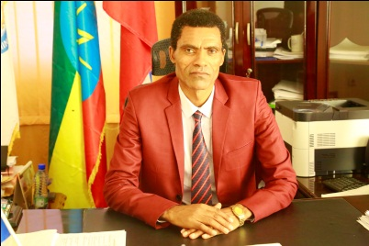 | Dr Damtew  Darza Sozo | President | +251- 46881 - 0771
 |  |  | +251–46881 0279
presidentoff@amu.edu.et
damtew.darza@amu.edu.et
 |  |  | MOBILE
 |  |  | +251-916831220
 |  |  | CAMPUS
 |  |  | MAIN CAMPUS
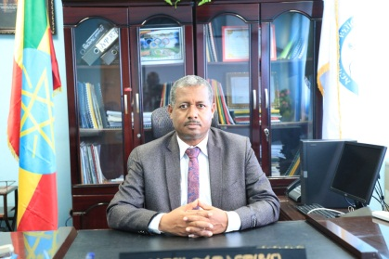 | Dr Alemayehu  Chufamo | Vice President for Academic Affairs | +251- 46881 0770
 |  |  | +251–46881 0279
 |  |  | alemayehu.chufamo@amu.edu.et
 |  |  | MOBILE
 |  |  | +251-935956420
 |  |  | MAIN CAMPUS
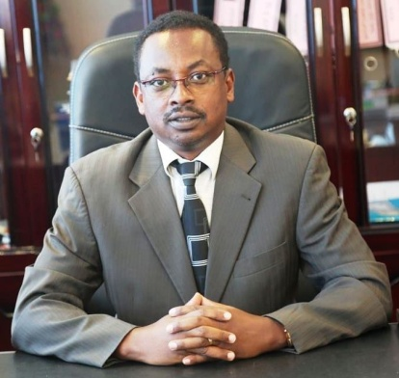 | Mr Behailu Merdekios | VP for Research & Community  Service | +251- 46881 0299
 |  |  | +251– 46881 0279/0820
 |  |  | EMAIL
 |  |  | merdekib@tcd.ie
 |  |  | MOBILE
 |  |  | +251-910441888
 |  |  | MAIN CAMPUS
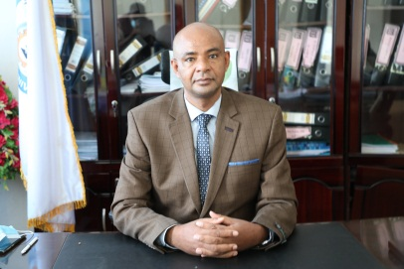 | Dr Melkamu  Mada | VP for Administration | +251- 46881 0534
 |  |  | +251–46881 0533
 |  |  | EMAIL
vpad@amu.edu.et
melkamu.mada@amu.edu.et
 |  |  | MOBILE
 |  |  | +251-911067253
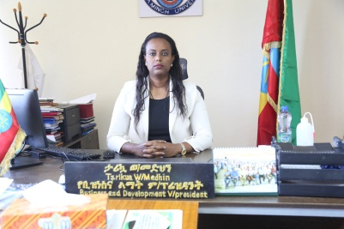 | Tarikua  Weldemedehin | VP for  Business & Development | +251- 468810 4190
 |  |  | MOBILE
 |  |  | +215913469469
 |  |  | EMAIL
 |  |  | tarikua.weldemedehin@amu.edu.et
 |  |  | MAIN CAMPUS
AMU’S FORMER PRESIDENTS
PHOTO | NAME | DESIGNATION | TENURE
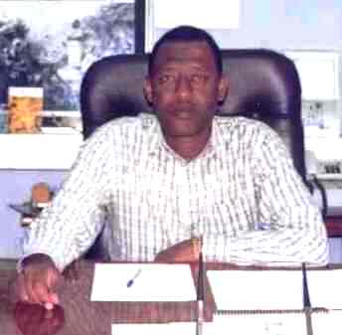 | Dr Nigatu Chaffo | 1st  President | APR 2004-OCT 2007
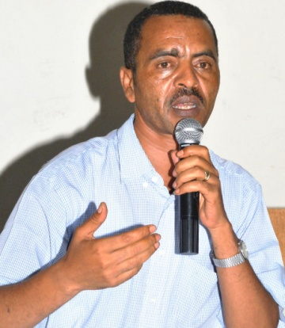 | Dr Tareken Tadesse | 2nd President | NOV 2007-FEB 2011
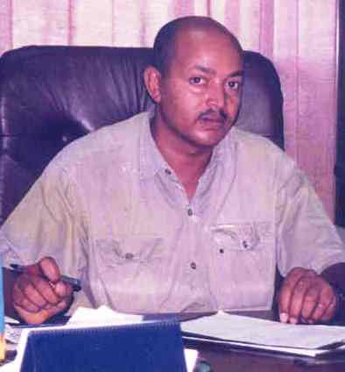 | Dr Joseph Biru | 3rd  President | MAR 2011-MAY 2012
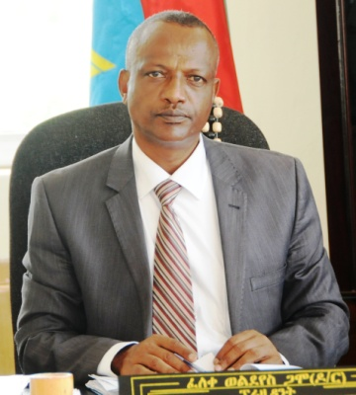 | Dr Feleke Woldeyes | 4th  President | JUNE 2012-MARCH 2016
ERSTWHILE AWTI DEANS
PHOTO | NAME | PHOTO | NAME
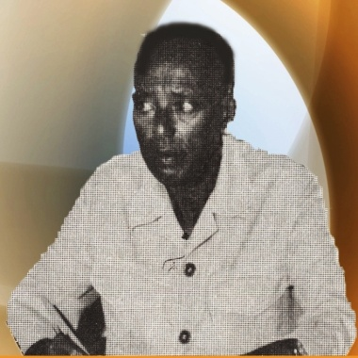 | 1st  Mr Ahmed Umer  FROM JULY 1986  TO  DECEMBER  1988 | 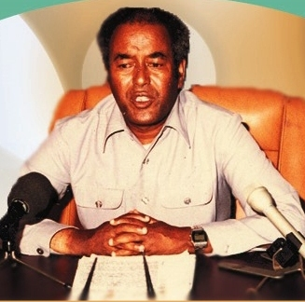 | 2nd  Mr Girma Muluneh  FROM JAN 1989  TO  DECEMBER  1991
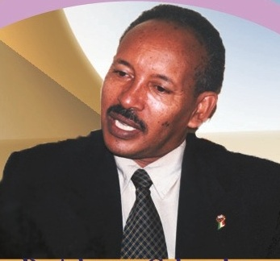 | 3rd  Dr Admasu Gebeyehu  FROM JAN 1992  TO  APRIL  1993 | 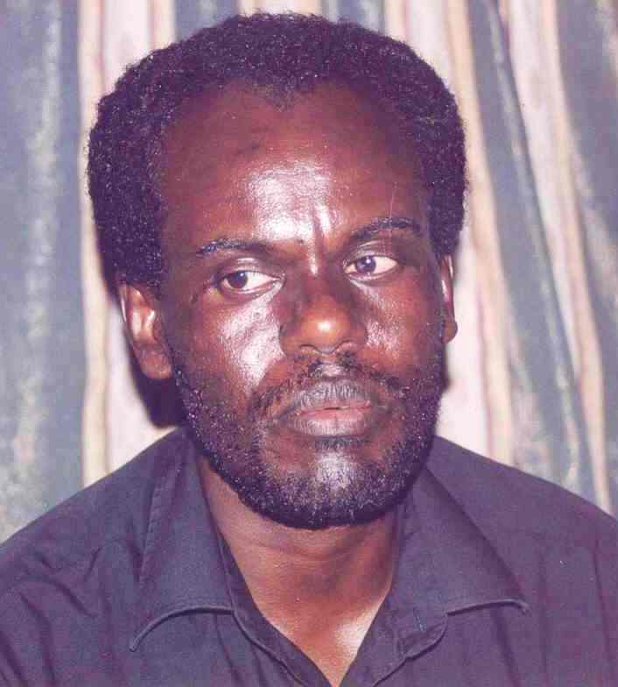 | 4th  Dr Ababu  Teklemariam  FROM May 1993  TO  NOV  1994
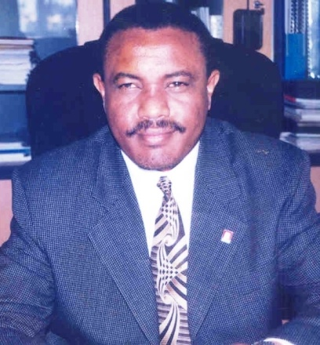 | 5th  Mr H/Mariam  Desalegn  FROM  DECEMBER  1994  TO  OCTOBER  2001 | 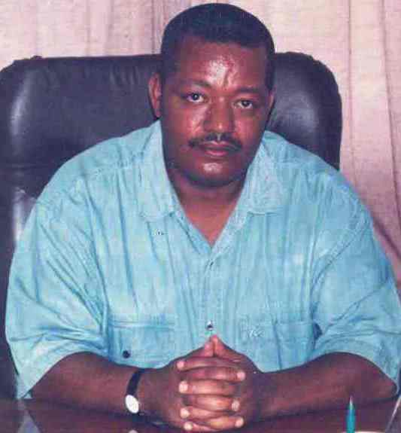 | 6th  Dr Bogale  g/Mariam  FROM  NOV 2001  TO  JULY  2002
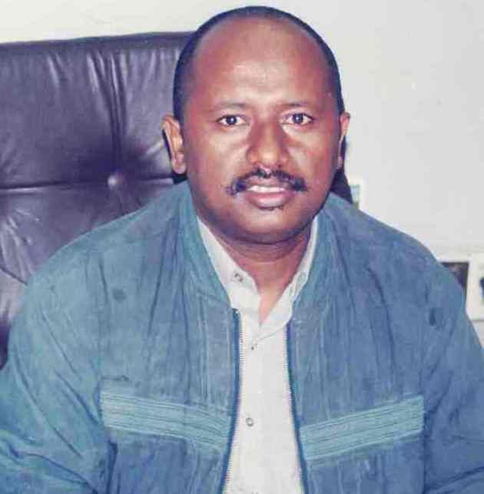 | 7th Dean  Dr Sileshi Bekele  FROM  AUGUST 2002  TO  MARCH  2004
ORGANIZATIONAL STRUCTURE OF AMU

Currently, the university’s top leadership positions constitute President office and four vice presidents’ offices that represent Academic Affairs, Research and Community Service, Administration and Business & Development. The administrative bodies under each top position are as follows:

UNIVERSITY PRESIDENT

The following 20 different bodies and offices accountable to President’s Office are:

- University Senate
- Managing Council
- University Council
- Vice President office for Administration
- Vice President office for Academic Affairs
- Vice President office for Research and Community Service
- Vice President office for Business and Development
- Scientific Director of Water Technology Institute
- Scientific Director of Institute of Technology
- Director of Institutional Quality Enhancement
- Director of Strategic Planning and Implementation
- Director of Communication Affairs Directorate
- Director of Information Communication Technology Directorate
- Director of Cross-Cutting Issues
- Director of Legal Service
- Director of Audit & Inspection
- Director of Females, Children and Youth Affairs
- Director of Ethics and Anti-Corruption
- Director of Institutional Transformation and Good Governance
- Dean of Deliver-ology Unit

VICE PRESIDENT FOR ACADEMIC AFFAIRS
The office of Academic Affairs Vice President accountable to University President holds the overarching academic responsibilities of facilitating, strengthening and providing momentum to teaching-learning process in the university, AMU’s first pillar. Thirteen offices accountable to the AAVP to assist in carrying out academic functions are:

- Dean of College of Natural Sciences
- Chief Executive Director of College of Medicine & Health Sciences
- Dean of College of Agricultural Sciences
- Dean of College of Business & Economics
- Dean of College of Social Sciences and Humanities
- Dean of College of Continuing and Distance Education
- Dean of School of Graduate Studies
- Director of Academic Program, Evaluation & Implementation Directorate
- Director of Library and Documentation Service Directorate
- Dean of School of Law
- Dean of School of Pedagogical and Behavioral Sciences
- Director of Sport Academy
- Registrar

VICE PRESIDENT FOR RESEARCH AND COMMUNITY SERVICE
The office of the Vice President for Research and Community Service is accountable to the President of the University. It leads two core processes i.e. Research and Community Service and University-Industry Linkage and Technology Transfer responsibilities. Offices directly or indirectly accountable to the Vice President for Research and Community Service are:

- Research Directorate
- Community Service Directorate
- University-Industry Linkage and Technology Transfer Directorate
- Water Research Resource Centre
- Collaborative Research and Training Centre for Neglected Tropical Diseases
- Gircha Highland Fruits and Vegetable Research Centre
- Renewable Energy Technologies Research Center
- Livestock and Fishery Resource Research Centre
- Behavioral and Social studies Research Unit
- Demography and Health Development Research Unit
- Entrepreneurship Development Centre
- Biodiversity Research and Conservation Centre
- Institute of Culture and Language Studies

VICE RESIDENT FOR ADMINISTRATION
The Vice President for Administration shoulders the administrative responsibilities evaluates and monitors wide range of activities in the university. Following eight offices are directly report to VPA:

- Director of Human Resource Development and Management Directorate
- Director of Procurement & Property Administration Directorate
- Director of Students Service Directorate
- Director of Finance and Budget Administration Directorate
- Head of University Security Office
- Director of Facility Management
- Director of General Service
VICE RESIDENT FOR BUSINESS AND DEVELOPMENT
The Vice President for Business and Development office not only consults and assists President regarding the powers and duties of the university, but also plans, directs, leads and supervises the implementation of agreements and projects related to business and construction with other organization. Similarly, it prepares and submits business and strategic plans as well.

Following three offices directly report to VPBD:
Director of Income Generation Directorate, Head of Construction Project Office and Head of AMU enterprises

STUDENTS DATA

Regular undergraduate students

Band | Institute/College | Regular
 |  | M | F | Total
1 | AWTI | 1,161 | 719 | 1,880
1 | AMiT | 2,829 | 794 | 3,623
2 | Natural Science | 914 | 591 | 1,505
3 | Medicine and Health Science | 1,003 | 506 | 1,509
4 | Agricultural Science | 443 | 338 | 781
5 | Business and Economics | 1,176 | 632 | 1,808
6 | Social Science and Humanities | 800 | 727 | 1,527
Total |  | 8,326 | 4,307 | 12,633

Non-regular undergraduate students

Band | Institute/College | Non-Regular
 |  | Extension |  |  | Summer |  |  | Distance |  |  | Total
 |  | M | F | Total | M | F | Total | M | F | Total | M | F | Total
1 | AWTI | 0 | 0 | 0 | 0 | 0 | 0 | 0 | 0 | 0 | 0 | 0 | 0
1 | AMiT | 600 | 213 | 813 | 1,256 | 344 | 1,600 | 0 | 0 | 0 | 1,856 | 557 | 2,413
2 | Natural Science | 404 | 127 | 531 | 2,535 | 857 | 3,392 | 0 | 0 | 0 | 2,939 | 984 | 3,923
3 | Medicine and Health Science | 145 | 94 | 239 | 92 | 17 | 109 | 0 | 0 | 0 | 237 | 111 | 348
4 | Agricultural Science | 0 | 0 | 0 | 711 | 161 | 872 | 0 | 0 | 0 | 711 | 161 | 872
5 | Business and Economics | 1,691 | 891 | 2,582 | 514 | 151 | 665 | 268 | 199 | 467 | 2,473 | 1,241 | 3,714
6 | Social Science and Humanities | 63 | 28 | 91 | 2,470 | 1588 | 4,058 | 0 | 0 | 0 | 2,533 | 1,616 | 4,149
Total |  | 2,903 | 1,353 | 4,256 | 7,578 | 3118 | 10,696 | 268 | 199 | 467 | 10,749 | 4,670 | 15,419

Band | Institute/College | Regular PG
 |  | M | F | Total
1 | AWTI | 202 | 29 | 231
1 | AMiT | 420 | 65 | 485
2 | Natural Science | 251 | 42 | 293
3 | Medicine and Health Science | 185 | 39 | 224
4 | Agricultural Science | 215 | 26 | 241
5 | Business and Economics | 226 | 36 | 262
6 | Social Science and Humanities | 205 | 28 | 233
Total |  | 1,704 | 265 | 1,969

Regular Master students

PhD Students’ data
Band | Institute/College | PhD students
 |  | M | F | Total
1 | AWTI | 12 | 0 | 12
1 | AMiT | 7 | 0 | 7
2 | Natural Science | 51 | 2 | 53
4 | Agricultural Science | 6 | 0 | 6
5 | Business and Economics | 30 | 3 | 33
6 | Social Science and Humanities | 24 | 1 | 25
Total |  | 130 | 6 | 136

AMU STAFF PROFILE
Academic data by Gender, Qualification, Rank and Nationality

QUALIFICATION | MALE | FEMALE | TOTAL
DIPLOMA | 89 | 7 | 96
DEGREE | 132 | 53 | 185
MASTER | 769 | 118 | 887
PHD | 190 | 7 | 197
Total | 1,180 | 185 | 1,365
ACADEMIC RANK
TECHNICAL STAFF | 154 | 29 | 183
LECTURE | 822 | 165 | 987
ASSISTANT PROFESSOR | 78 | 4 | 82
ASSOCIATE PROFESSOR | 39 | 0 | 39
PROFESSOR | 18 | 1 | 19
TOTAL | 1,111 | 199 | 1,310
STAFF ON STUDY LLLLLLEAVE | M F  F
 | 598 | 126 | 724
OVERALL TOTAL | 1,709 | 325 | 1,945
NATIONALITYWISE | M F
ETHIOPIAN | 1,709 | 325 | 2034
EXPATRIATE | 114 | 13 | 127
TOTAL | 1,832 | 337 | 2,161

LIST OF TECHNOLOGIES TRANSFERRED TO COMPANIES

S.N | New Technologies Transferred/In the Pipeline | Remark
 | Banana fiber extracting machine | Needs modification
 | Improved ILCA internal Agitator | Transferred
 | Injera Baking Machine | On the pipeline to transfer
 | Sliding Board | Transferred
 | Milk Churner | Transferred
 | Maize Sheller | Transferred
 | Hydraform Brick-making Machine | In the pipeline
 | Screw driver (‘Aitkini’) | In the pipeline
 | Groundnut sheller | In the pipeline
 | Sensor-based hand wash machine | Transferred
 | Automatic disinfectant sanitizer for workplace | Transferred
 | Ethanol distilling machine | Transferred
 | Sanitizer dispenser | In the pipeline
 | Innovative Enset Technology for gentle processing, value-added products, safe storage, longer shelf life | In the pipeline
 | Water heater ( micro-boiler) for bathroom | In the pipeline

NUMBERS OF PATENTS AWARDED

S.N | Name of Technology | Patent Right Status
1 | Electrical Train | Patented
2 | Sliding Board | Patented
3 | Screw Drver (Aitikin) | Patented
4 | Maize Sheler | Patented
5 | Innovative Enset Technology for gentle processing, value added products, safe storage and longer shelf life | On the way
6 | Ethanol producing machine | On the way
7 | Sensor based hand wash machine | On the way
8 | Hydraform Brick Making Machine | On the way

INTERNATIONAL COLLABORATIONS

- 2nd Phase of NORAD Project inked to advance quality of Research at AMU
- Oxford Brookes University to strengthen legal study, staff exchange and capacity building
- EU project AGRUMIG to enhance agricultural practices and livelihood in rural communities
- Partnership with International Centre of Pure Applied Mathematics of France will give sustained fillip to research in mathematics
- Pact with International Union for Conservation of Nature & GIZ to revive Chamo basin
- 5-year MoU with KU Leuven, Belgium to promote joint research and capacity building
- 4-year Joint Project - RUNRES is aimed at establishing circular economy in Ethiopia
- AMU-IUC collaboration for six mega projects in SNNPR is underway with AMU’s 17 staff members pursuing PhD/pre-doctorate studies in Belgium
- Project, REALISE with Wageningen University & Research, Netherlands to ensure food security, improve livelihood and build institutional capacity in 16 kebeles of Gamo, Gofa and Segen Area Peoples Zone.
- Tripartite agreement Chinese Guangxi Vocational & Technical Institute to enhance sugar production across Ethiopia is likely to change demand-supply equation.
- With Washington University and University of Tennessee for staff exchange and e-learning
- 5-year agreement with Vellore Institute of Technology, India, all set to strengthen research initiatives, staff development and students’ exchange
- AMU- Tsehai Corporation (US-based) pact will help develop a world-class research center on Ethiopian studies, to ensure competitive, cutting-edge research and learning milieu.

AMU’s NATIONAL ASSOCIATIONS

- UIL-TTD-International Institute of Rural Reconstruction join hands to transfer knowledge, research outputs for societal gains
- MoU with SNNPR-ICT, Hawassa, is establishing ICT incubation centre
- AMU closely working with Ethiopian Public Health Association on de-worming
- AMU leading Regional Moringa Task Force to exploit moringa’s full potential
- AMU collaborating Ethiopian Leather Development Institute to promote joint research
- With Lucy Consulting Engineers PLC on online education, training & technology transfer
- MoU with Ethiopian Biotechnology Institute for National Biotechnology Grant Program
- AMU-Hawassa Ceramics working on HR development, research, technology transfer
- AMU is collaborating with Ethiopian Intellectual Property Rights on allied issues
- AMU-Communication Technology Agency joined hands for collaborative research
- MoU with Ministry of Water Resources, Irrigation and Electricity for technical cooperation
- AMU-Bishoftu Automotive Engineering to work on research, technology transfer
- AMU is collaborating with Stem Power Incorporation

CONTACT US

Communication Affairs Directorate
Office Phone: +251 46881 4986/3167
Fax Number: +251 46881 4964/0279
Website: www.amu.edu.et
Facebook: arbaminchuniversityccd
Email: corcom@amu.edu.et

